I tested Gemini Shopping on Brazilian e-commerce. This is Google's system working as designed

Eva Bettina De Paula
Senior Product Manager | Technical PM | B2B & B2C E-commerce | Staff-level IC | SEO · Performance · Data · AI | A-CSPO®
June 9, 2026
As you know, I'm currently building my MBA thesis at USP around a framework we could call the Agent-Readiness Score (ARS) , a way to measure how readable a product page is for AI agents. To collect the data, I built a pipeline in GCP that runs 3x daily across 7 fixed SKUs and multiple Brazilian e-commerce stores, storing everything in BigQuery. Just a little recap: I chose two specific product categories for my research (skincare and electronics) due to differences in the entities that each one holds.
I dedicated this past weekend to organizing my pipeline in GCP and running the simplest test I could to verify if the data I'm collecting mirrored the actual behaviour in the storefronts. I queried Gemini using the Flash model and my own account to do that. I need to register that I use my everyday Gemini account, which could theoretically generate a bias in my research. Why is it important to mention that? I had an amazing talk last week with someone who mentioned how an AI agent could ignore structured data and recommend something based purely on our chat history instead.
But for this example, I used Gemini and Google Search as we used to search in the past: the Flintstones era. In this article, I want to share what I found, being clear about what I can claim vs. what is a hypothesis.

We need to talk about queries
As we know, people search in different ways, and there are different types of queries when it comes to traditional SEO: informational, navigational, transactional, and commercial investigation queries. In this article, let's call investigation queries comparison queries.
When I was choosing the URLs to use in my research, I chose the exact same product in every store. Let's use this example: iPhone 17 Pro orange 256GB. Remember that my research is focused on the Brazilian market, so "orange" becomes "laranja" in Portuguese. Let's call this a very specific comparison query:
"Compare iPhone 17 Pro laranja 256GB nas principais lojas brasileiras: preço, disponibilidade e frete." (In English: Compare the price, availability, and shipping costs of the orange iPhone 17 Pro 256GB at major Brazilian retailers.)
This was not a buying query yet; we aren't talking about the bottom of the funnel, but more about the middle stage of transactional intent. For retailers, however, it is an opportunity to be discovered by the customer. Why did I choose this type of query specifically? Because this is the exact kind of task that AI shopping agents are explicitly built to handle. It is one of the first and most natural tasks in this early stage of agentic commerce integration, where Google Shopping Graph, MCP, and other protocols are still maturing. The evidence is right there in the sidebar Gemini just showed me.
In this stage, the user's goal is comparing products using the most important features they care about. It is a tedious task that humans often get wrong, but agents do it exceptionally well. The customer knows what they want to buy and is asking for the best channel to do it.But what happens if your store doesn't allow a crawler to do its job? Agents need to parse your content. If we don't allow these crawlers... What can they recommend?

Well, let's see the result
As we can observe above, Gemini opened that amazing sidebar. Google launched it in the US in November 2025, and in Brazil in May 2026. Google calls it Gemini Shopping (or AI-powered shopping assistant), and it relies heavily on the Google Shopping Graph.
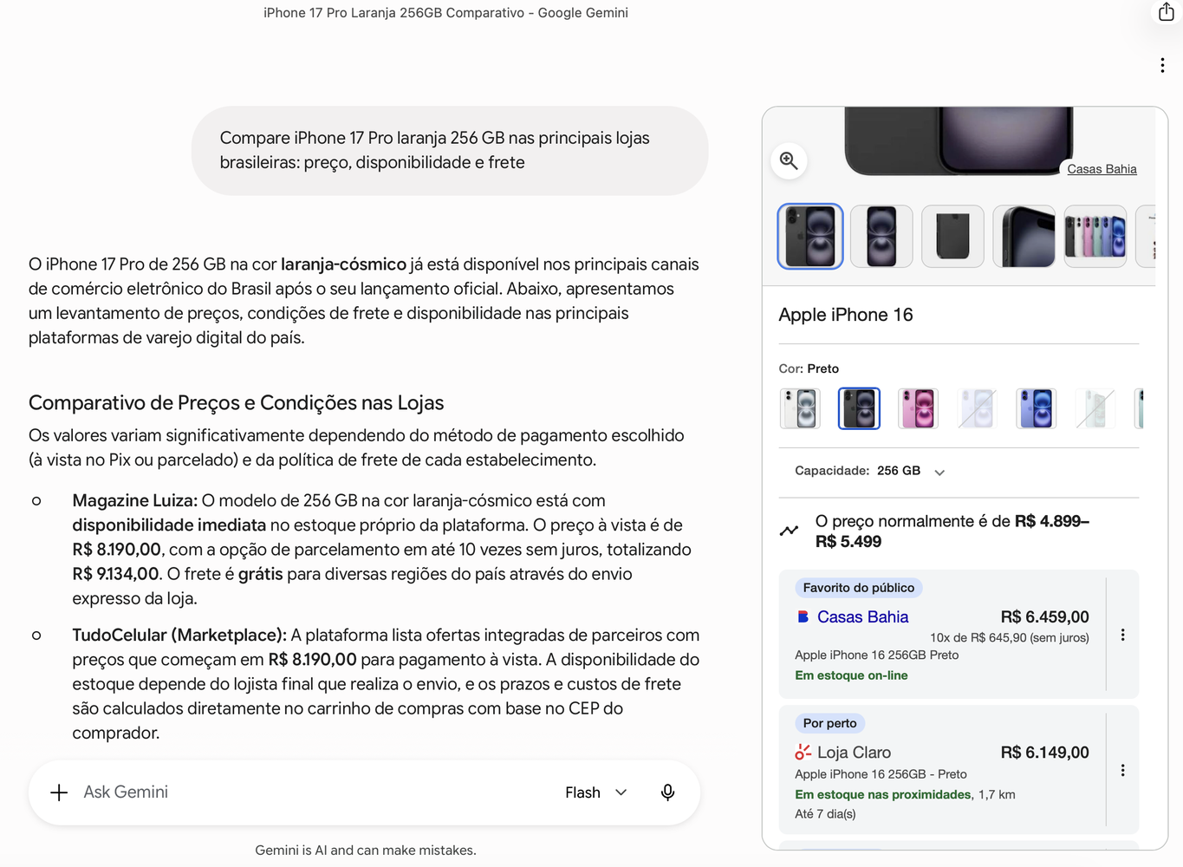
Magazine Luiza vs Casas Bahia :-O
It pulled structured product data: price, stock, shipping time, and a filter for capacity (remember, I specified 256GB). We can see data from multiple stores simultaneously. It's not a simple list of links like a traditional SERP; it's actual structured comparison data rendered in a wonderful panel next to the text response.
But we can observe a massive difference between the answer in the chat and the sidebar. Can you see Magazine Luiza at the top of the chat, but Casas Bahia as the first store on the sidebar?

Ops, in conversational chat Magalu is the recommended store.
Look closely at the conversational text: Gemini explicitly recommends Magazine Luiza as the best choice for "cost-benefit and delivery security." The LLM clearly recognizes Magalu's brand authority and historical reliability. Yet, in the actionable-clickable-filtered Shopping sidebar right next to it, the space designed to drive the actual transaction, they plummeted past position #40.
This is like a Split-Brain Paradox of AI: brand authority wins the semantic chat, but data architecture loses the transactional shelf space. It proves that SEO and GEO/AEO are completely different games (Is this true?). But let's hold that thought; I am going to deep dive into this specific paradox and explain how LLMs split their "brains" between history and real-time data in my next article.

Two-brains?
Interesting, right? Let's focus on Magalu. This is a massive, giant store in Brazil. If we use the exact same query on Google Shopping, nobody beats them there:
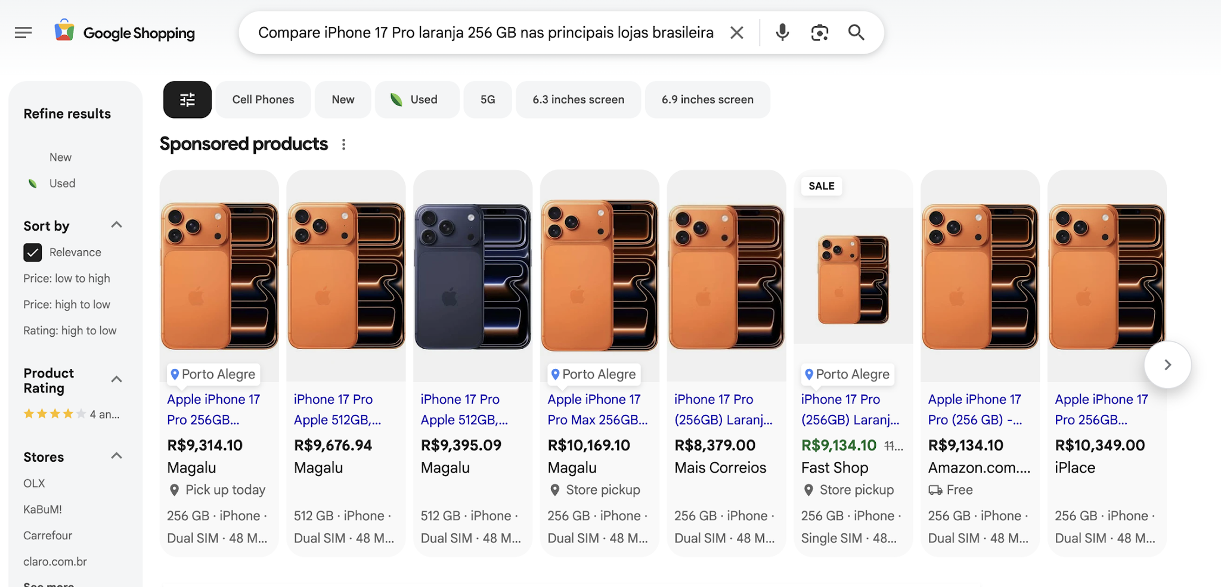
Google Shopping results to the same query
Magazine Luiza holds the first four results. But in the Gemini sidebar, Magazine Luiza appears in... well, I don't know exactly, I stopped counting at position #40. It is not the best customer experience.
Play
Magalu sideber results
I'm mentioning this because the first time I ran the query on Gemini (Saturday), Magazine Luiza appeared at #47. Today (Monday), it appears past #60. We can infer that this ranking is dynamic. Without fresh data, the ranking gets progressively worse. I need to monitor this over time as another dimension within my historical data series. In the SERP, Magazine Luiza appears in the first position in ads, but it doesn't even appear on the first page of organic results.
But we can try to cheat Gemini, right? If I use a less specific query, could Magazine Luiza appear in the results in a better position?
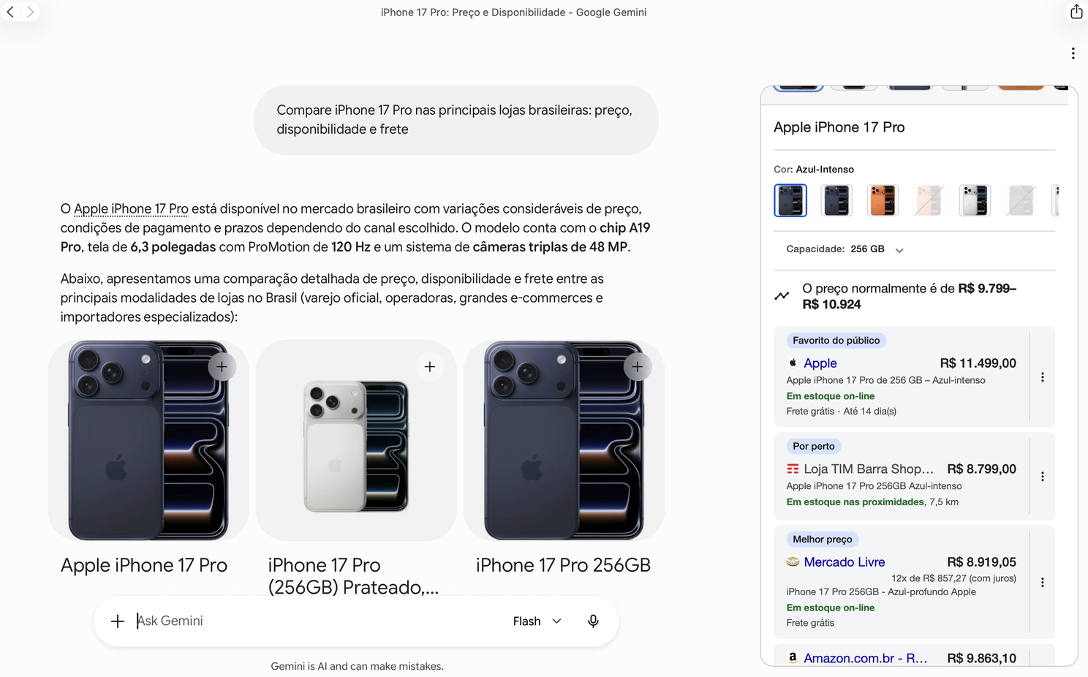
Apple wins
The "favorite store" label changed when I used another query. Apple appeared at the top of the sidebar result. Now we know it is dynamic and heavily dependent on the query. Because this last query was less specific about the product itself, I initially thought Magazine Luiza didn't appear because they didn't stock the orange iPhone. I had to check their site to verify I wasn't hallucinating:
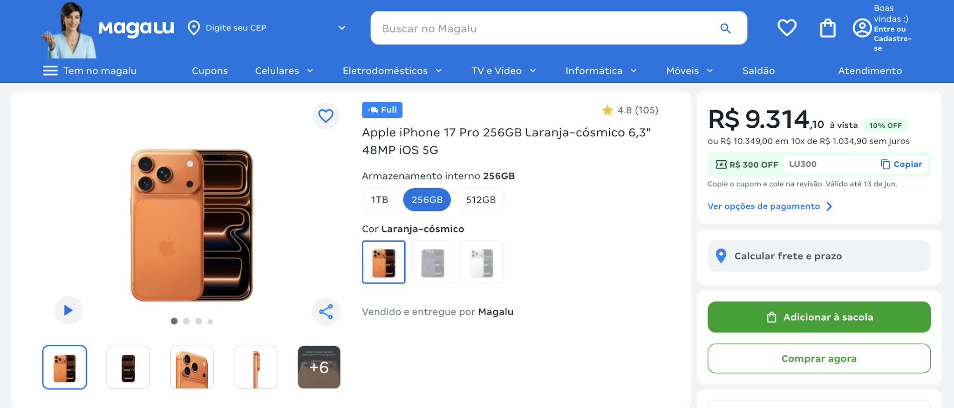
Everything fine with the product. I guess.
Magazine Luiza had the product available to purchase on the site, and everything was fine.

The Google Merchant Center Rules at Play
It seems we are finally seeing the Google Merchant Center guidelines working in the wild. The documentation explicitly explains that Google crawlers - specifically Googlebot (general web) and GoogleStoreBot (inventory validation, price, and checkout) - cannot be blocked on Product Detail Pages (PDPs).
Disclaimer: I use ( - ) because I’m very tired trying to figure out how to write in a better way in a language that is not my mother tongue. It is not AI, it is me, tired.
Google warns that blocking its bots (whether via robots.txt, IP blocks, or anti-bot systems like Akamai) generates destination page errors. If the bot can't access the page, it cannot validate the offer. Another crucial point in their documentation is the "Allow Merchant Center to update product information automatically" feature. This is the definitive proof of their dependency on Schema.org. Google affirms that it uses structured annotations directly in the website's code to verify the price provided in the feed.
Google also has a policy for Preemptive Item Disapproval. Translated into plain English, this means the information in the Merchant Center must match exactly what is on the website for that product. But what happens if the crawler gets a 403 Forbidden error, like the one (two, three, four and counted) I received from Magazine Luiza? The product could be totally removed from the Shopping Graph and, consequently, from the AI-powered-I-have-power-and-all-your-data Gemini Shopping experience. I believe I am observing an active Google penalization on Magazine Luiza due to crawler failure.
A huge disclaimer here: I used just Gemini for this first test because Google has the richest data environment in the universe. Google's products are like Infinity Stones: Merchant Center, Manufacturer Center, Search Console, CrUX, Knowledge Graph, Shopping Graph, GA4, YouTube, Google Ads, Business Profiles. Each one feeds the others. An agent inside this ecosystem sees a completely different world than an agent outside it. Every company creates its own Ads ecosystem, but we know the uphill battle required to compete against Google.
Claude, ChatGPT, and Perplexity cannot access the Shopping Graph or Merchant Center. They depend on their own APIs and crawlers, or third-party search APIs like Bing. When a store implements rigid anti-bot rules or whitelist access permissions just for Google, it becomes invisible to the other agents outside the Google ecosystem. My humble test with BeautifulSoup simulates the exact barrier that an autonomous, independent agent hits when it tries to make a direct HTTP request. Because of that, I added another layer to my research regarding access hierarchy.

The Access Hierarchy My Pipeline Reveals
When I built my data collection pipeline, I discovered that Brazilian e-commerce sites fall into distinct categories based on how accessible their product data is to non-Google crawlers. I split the e-commerce sites into three categories:
- Category 1: Openly accessible (The researcher's best friend): Americanas, Kabum, Samsung D2C. Schema.org is captured by my scraper, validated by the schema.org validator, and indexed by Google with Rich Results. These stores are readable by any agent, inside or outside the Google ecosystem.
- Category 2: Accessible to Googlebot only: Vivo, Boticário. Schema.org exists (I can see it in DevTools), but the site blocks any request that doesn't come from a real browser. The schema.org validator returns "URL not found," and my scraper returns nothing. Yet, Rich Results appear in the SERP, meaning Googlebot successfully reads the schema. These stores are invisible to direct agents but visible inside the Google ecosystem.
- Category 3: Blocked entirely (The anti-research team): Magazine Luiza. Returns a 403 page with the message "Não é possível acessar a página." Their robots.txt returns 403 for all user agents. Schema? None. Rich Results? Also none.. It was so heartbreaking, Magalu. I put all my bets on you.
Let's recap my approach to crawling these pages. My pipeline uses static HTML extraction: requests + BeautifulSoup. No JavaScript rendering, no browser fingerprint, no session cookies. It gets identified and blocked immediately by any serious anti-bot system. Magazine Luiza uses Akamai as a CDN, so I believe they are using Akamai Bot Manager for enterprise anti-bot protection (cries in Python).
I'm using this approach because I'm not trying to bypass anything. I need to simulate what a direct AI agent does when it accesses a page: a plain HTTP request, no full browser stack. If my scraper gets a 403, a direct agent probably does too. I asked my security oracle, my amazing ex-colleague Daniel Daniele , if there could be another approach I could use legally 😛. He mentioned tools like Browserless, ZenRows, and ScrapingBee can get around this. But they simulate a human browser, which is not how AI agents access pages today.

Brand Authority vs. Transactional Data
Apple appears first. But why not always? The label "Favorito do público" is not fixed. When I searched generically for the iPhone 17 Pro across Brazilian stores, Apple appeared first. Brand authority wins here: iPhone = Apple in the Knowledge Graph, and all historical signals point to apple.com. Traditional SEO is not dead. We’re so back after all the hype with "new SEO approaches".
But this isn't because apple.com loads fast. My data shows Apple's LCP on mobile is 6,184ms, which is "Poor" by Google's Core Web Vitals standards. Performance did not determine this ranking. When I added specific transactional dimensions to the query (color, storage, price, availability, and shipping), Casas Bahia moved to the top. This pattern is consistent with Google's own guidelines for rich results: for commercial investigation queries, the AI prioritizes entity accuracy, price, and availability extracted from structured data over brand authority and page performance metrics.
The closer we are to a transaction, the more structured data wins over brand recognition. Five days of data (I set up two dollars in GCP, hoping these two dollars could make miracles a real thing) and two queries, and the pattern consistently holds up to Google's documentation.
As of June 9, 2026, I have more data: the pattern holds.

Specialist Stores vs. Generalists
iPlace, Horizon Play, and Claro Brasil appeared consistently in the top results of the Gemini sidebar before Brazil's largest retailers. Why?
They are specialists: iPlace is Brazil's largest authorized Apple reseller, Claro is a telecom giant, and Horizon Play is a premium Apple specialist. None of them have the traffic volume or product breadth of Amazon, Magazine Luiza, or Mercado Livre.
What I can observe is the outcome: specialized retailers with deep product focus ranked above generalist marketplaces with significantly more overall traffic and brand recognition. The hypothesis that open crawler access correlates with higher visibility in agent-powered comparisons remains to be fully tested on these specific stores, but it's a gap worth closing in the next research iteration.

The Coordination Problem Nobody is Talking About
As a Product Manager, I can't stop thinking about agent visibility as the outcome of decisions made across teams that probably never sat in the same room: the security team configuring Akamai Bot Manager, the frontend team building the PDP, the data/commercial team managing the catalog, the SEO team implementing Schema.org, and the platform team controlling CDN rules.
It took me a lot of time to stop thinking I was a storefront PM and realize I was actually a coordinator-staff-every-team-necessary-to-do-the-front-works-right manager.
None of these teams made a deliberate decision called "block AI agents." They made isolated decisions that, in combination, produced that outcome. It is a crime without suspects.

Without suspects?
There is a broader shift happening here that product and data teams need to internalize. Organic search results are losing real estate. Every SERP has more ads, more AI Overviews, more Shopping carousels, and more features that push the ten blue links further down the page. The fight for organic visibility is getting more expensive and less predictable.
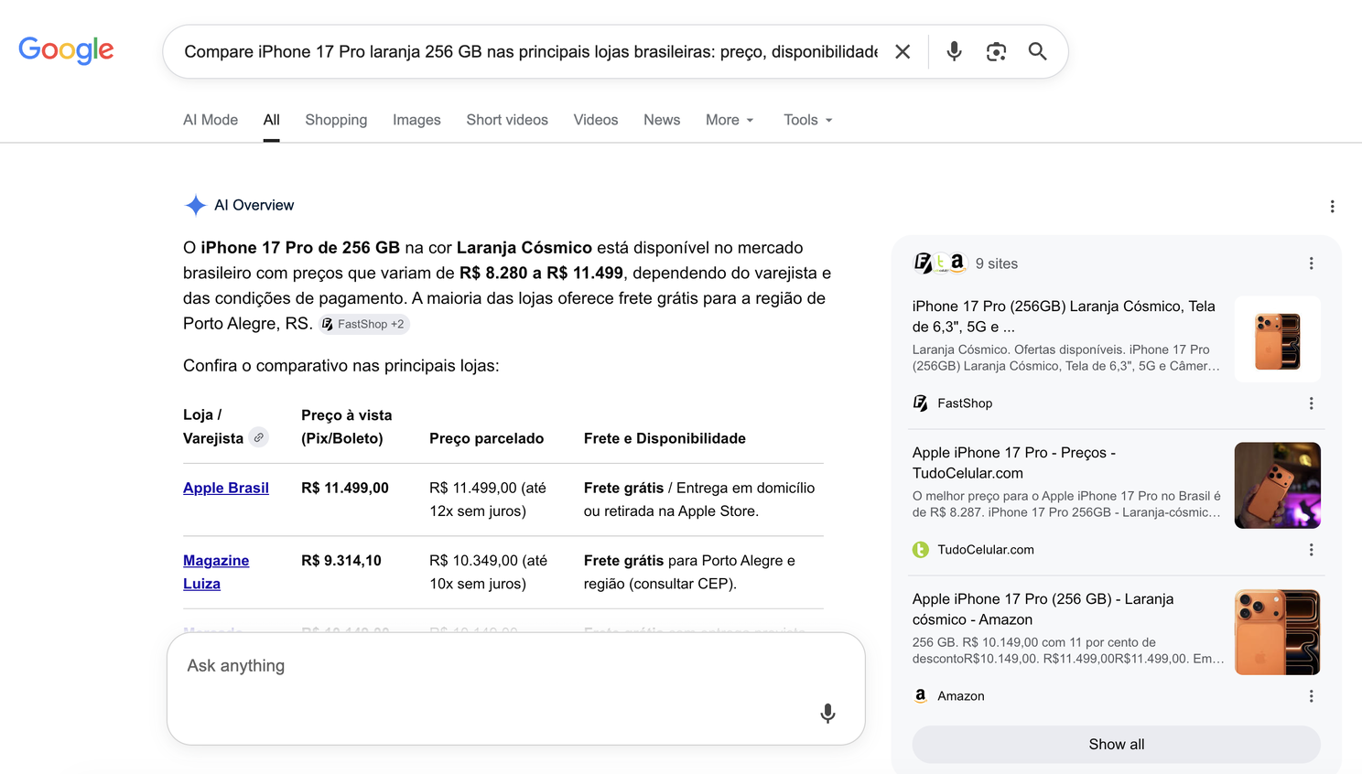
It Is almost impossible find organic results
If the customer is in the middle of the funnel, if they know exactly what they want to buy, they are looking for dimensions that live in your schema: price, delivery, offers, installments. If agents can't parse that, you're losing revenue.
A new entry point for commercial intent is emerging. It is not paid, not based on backlinks, and not determined by content volume. It is determined by data architecture. How structured is your product data? How accessible is it to crawlers? How complete are your transactional fields?
Technical teams have always been the unsung heroes of e-commerce revenue ( I love you team). But the paradigm is shifting because in the past, marketing teams could compensate for technical debt with massive content output, backlinks, and brand authority. In the agentic era, those workarounds don't exist. If your platform's CDN blocks a bot, or if your frontend doesn't render Schema.org cleanly, your brand authority is completely useless. The architectural decisions made by data engineers, frontend developers, and platform teams are no longer just supporting the marketing strategy, they are the strategy for AI-powered comparison surfaces. The force is with you.
This is not traditional SEO even though it is not performance marketing. It does not have a name yet that everyone agrees on. But treating data accessibility as a core product feature is becoming one of the most important levers for online revenue that most e-commerce organizations are not measuring.

The Product Management Opportunity
If you can measure agent-readiness systematically (which is what my pipeline does), you can integrate that measurement into your CI/CD pipeline. Every frontend deploy should be tested not just for visual regression and performance, but for agent-readiness.
Did this deploy break Schema.org parsing? Did it introduce a crawler rule that now blocks direct agents? Did it reduce the structured data fields that the Shopping Graph depends on?
That test suite does not exist yet for most teams. Building it is not an engineering problem; it is a product problem. It requires someone to define what "agent-ready" means, measure it continuously, create accountability across teams, and start the loop over again. We have a whole new ecosystem of AIs to think about now, and each one is different.
What a time to be alive. What a topic to wake up to every day.

The Honest Disclaimer: This is exploratory research. My pipeline has 5 days of data. I used Gemini Flash, not Pro. My account had no prior smartphone search history, which means the agent was not biased by my personal purchase history, strengthening the validity of what I observed. The query was in Portuguese. All of these variables matter.
What I can say with confidence: the data from my pipeline reveals a clear pattern of how access architecture dictates visibility. That's what the next 4 months of systematic collection are for.
I'm publishing this as part of an ongoing series on Agentic Commerce Optimization, the research behind my thesis. Follow along if you want to see where the data leads.
"In case I don't see ya... good afternoon, good evening, and good night!" Truman Burbank
Eva de Paula

